 **Caregiver Benefits Application  
VA Form 10-10CG**

Version 1.2  
Last Modified: January 10, 2025

Revision History

| Version | Date | Author | Changes |
| --- | --- | --- | --- |
| 1.0.0 | 04/29/2021 | Dené Gabaldón | Initial version |
| 1.1.0 | 05/26/2021 | Alayna Abel | Revision for Sign-as-a-Representative release |
| 1.1.1 | 07/09/2021 | Chris Dyer | Improved file upload error messaging |
| 1.1.2 | 06/09/2022 | Mark Fallows | Revision for Sign-as-a-Representative update |
| 1.2 | 07/11/2024 | Heather Justice | Revision for web components and new fields |
| 1.3 | 01/10/2025 | Heather Justice | Revision for new Facilities selection process |

Table of Contents

Overview

User Access

Who can access this application?

Navigation

Maintenance windows

How Do I Apply?

Program of Comprehensive Assistance for Family Caregivers (PCAFC) Application

Veteran information

Veteran health care information

Primary family caregiver selection

Primary family caregiver information

Secondary family caregiver selection

Secondary family caregiver information

Additional secondary family caregiver information

Representative documentation

Review and Submission

Reviewing the application

Signature section

Submitting the application

Troubleshooting a submission error

Table of Figures

# Overview

VA’s Program of Comprehensive Assistance for Family Caregivers (PCAFC) provides support and services to caregivers of eligible Veterans who have incurred a severe injury in the line of duty either on or after September 11, 2001, or on or before May 7, 1975.

To apply for PCAFC, Veterans and Family Caregivers must complete VA Form 10-10CG. This product guide provides instructions on the application process for online submission. The online application can be used to apply with a primary family caregiver and up to 2 secondary family caregivers. The online form can accommodate applications with:

* Veteran and primary family caregiver
* Veteran, primary family caregiver, and secondary family caregiver
* Veteran, primary family caregiver, secondary family caregiver, and additional secondary family caregiver
* Veteran and secondary family caregivers
* Veteran, secondary family caregiver, and additional secondary  
  family caregiver

The application supports the completion of the online application by Veterans with a legal representative (such as a legal guardian). Representatives can upload their documentation and sign their name on behalf of the Veteran.

VA’s Caregiver Support Program offers a wide variety of support services for caregivers of Veterans. Partnerships continue to be created or enhanced to broaden services and support for caregivers. Learn more by visiting the [Caregiver Support Program](https://www.caregiver.va.gov/) website or by calling the Caregiver Support Line at 855-260-3274 for more information.

## User Access

### Who can access this application?

Veterans and family caregivers complete this application. Each application can include a primary family caregiver and up to 2 secondary family caregivers.

Veteran information is required for every application, and each family caregiver applicant must complete their section of the form. The Veteran and all family caregivers must check the confirmation boxes on the submission page.

Compared to other forms on VA.gov, applicants do not sign in to complete the online version of the 10-10CG. You can reference Fig. 1 below screenshot for more eligibility information:

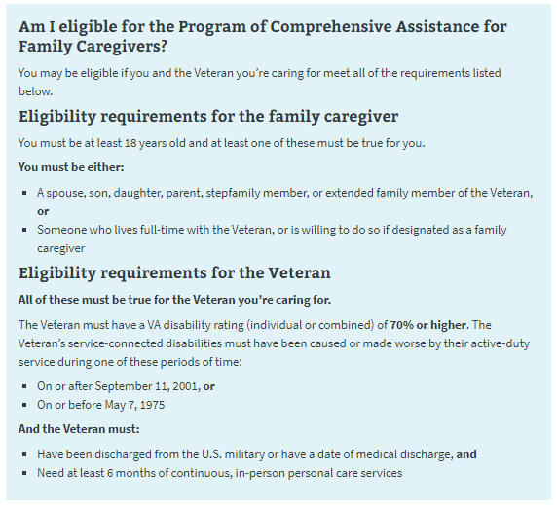  
*Fig. 1. 10-10CG eligibility information.*

### Navigation

Begin the application at <https://www.va.gov/family-and-caregiver-benefits/health-and-disability/comprehensive-assistance-for-family-caregivers/apply-form-10-10cg/introduction>(see Fig. 2).

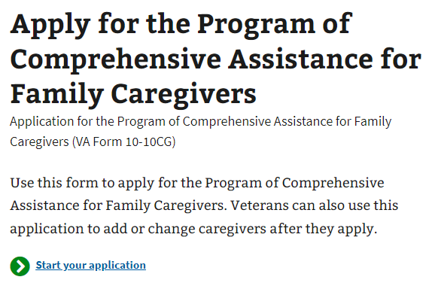  
  
*Fig. 2. Beginning the application.*

The Program of Comprehensive Assistance for Family Caregivers page (<https://staging.va.gov/family-and-caregiver-benefits/health-and-disability/comprehensive-assistance-for-family-caregivers/>) provides information about the program and a link to the form. See Fig. 3.

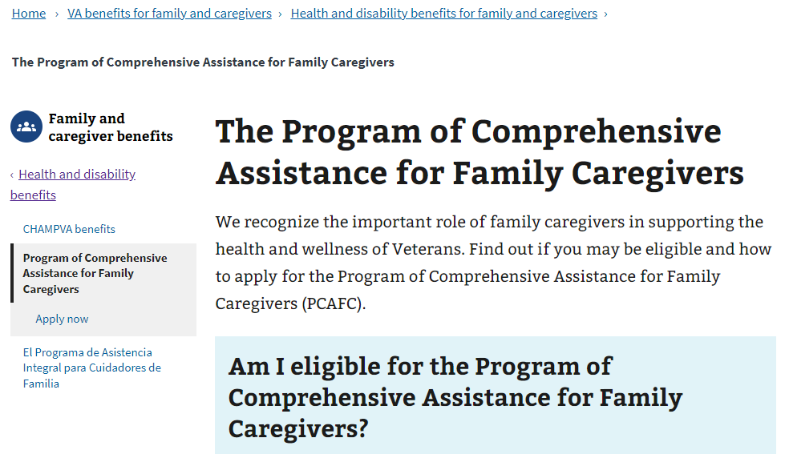  
*Fig. 3. Information on the Program of Comprehensive Assistance for Family Caregivers.*

### Maintenance windows

The technical systems that support the online family caregiver application undergo occasional maintenance. During this time, any online submissions will not go through. When such a maintenance window is coming up within 1 hour, users who navigate to the online form will see this message (Fig. 4), which specifies when the maintenance will begin and end:

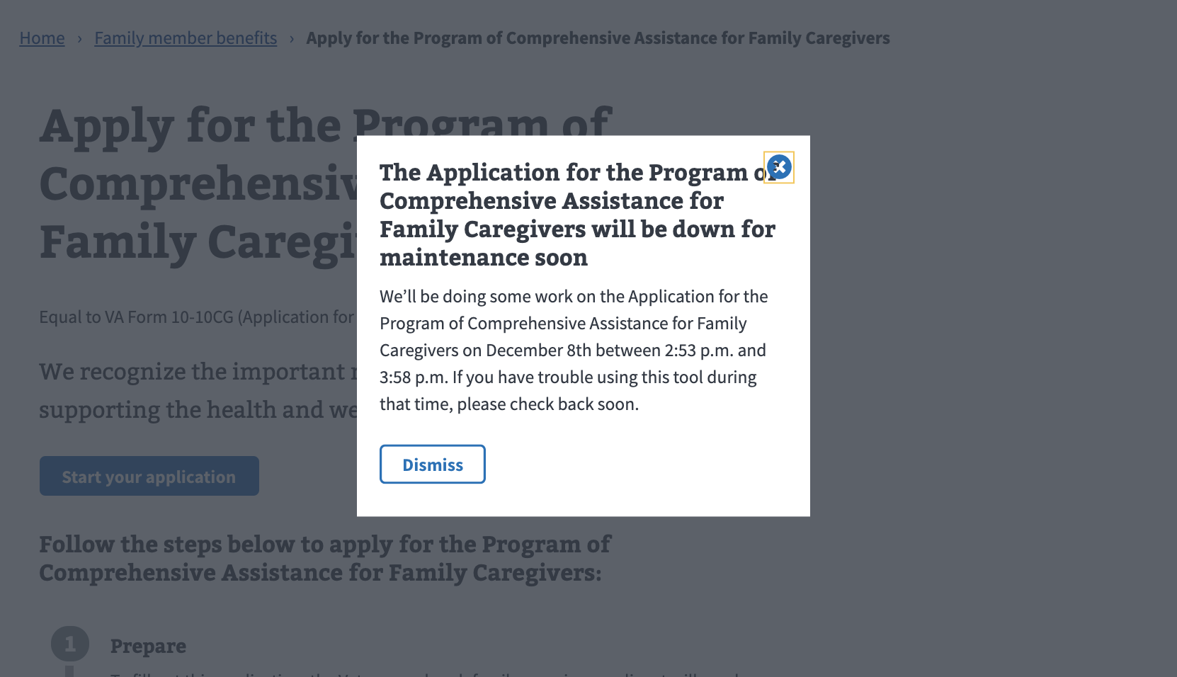  
*Fig. 4. Notice of upcoming scheduled maintenance.*

If the user navigates to the form once a maintenance window is underway, they will see the following message (Fig. 5) and will be unable to start the online application:

*Fig. 5. Tool unavailable due to maintenance.*

How Do I Apply?

The application page provides instructions on how to apply for the Program of Comprehensive Assistance for Family Caregivers and what information is needed to complete the form (Fig. 6). This page also directs the user to the application once they are ready to apply.

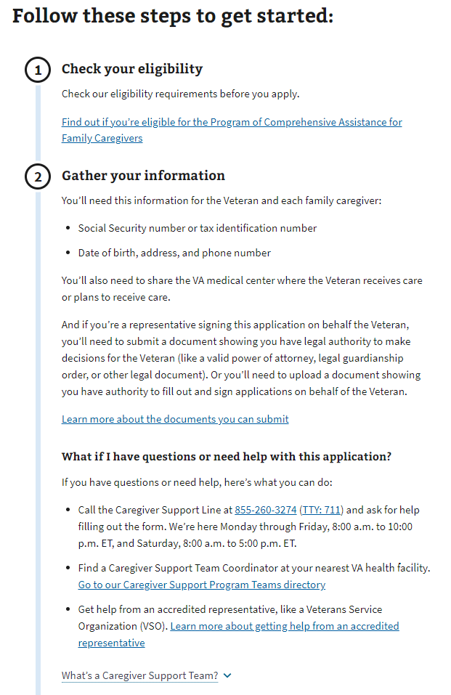

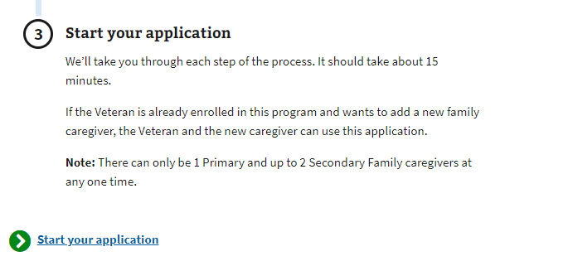*Fig. 6. Pre-application information for the comprehensive assistance program for family caregivers.*

A drop-down link gives applicants additional information about the Caregiver Support Team (Fig. 7).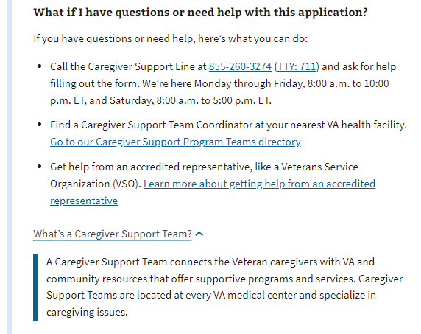  
*Fig. 7. Caregiver support program staff member information.*

# Program of Comprehensive Assistance for Family Caregivers (PCAFC) Application

### Veteran Information

First, the Veteran will be asked to fill in general personal information (Fig. 8).

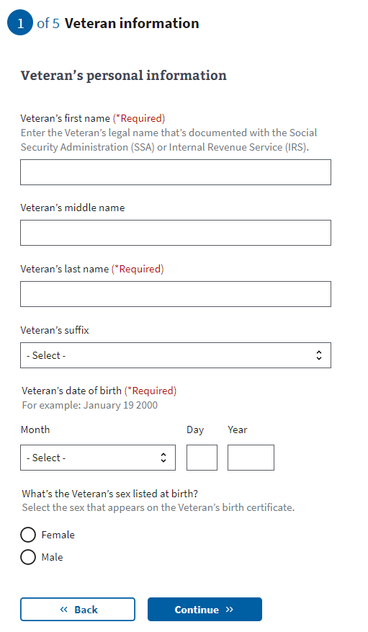  
*Fig. 8. General Veteran identification information for the 10-10CG application.*

The application will tell the Veteran what to fill in. They can only proceed to the next page if they enter all the required information.

The Veteran’s Social Security number or tax information number is needed to process the 10-10CG form online (Fig. 9). If they don’t supply a number, they will receive an error message.

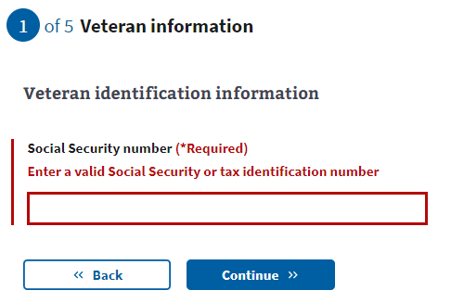

*Fig. 9. Area where the user enters Veteran’s Social Security or tax information.*

A Social Security or tax identification number is not required to apply or participate in the program. If the Veteran doesn’t want to supply their Social Security or tax identification number, they can still apply by downloading a copy of the form to fill out, sign, and send to VA via mail.

Next, the Veteran will be asked to fill in contact information (Fig. 10).

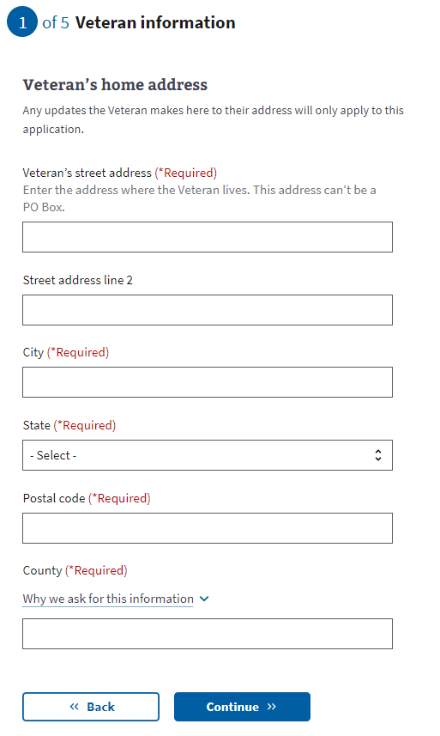

*Fig. 10. Veteran contact information.*

The primary phone number (Fig. 11) is required so a Facility Caregiver Support Program Staff member can contact the Veteran to discuss the application. Email is not a required field.

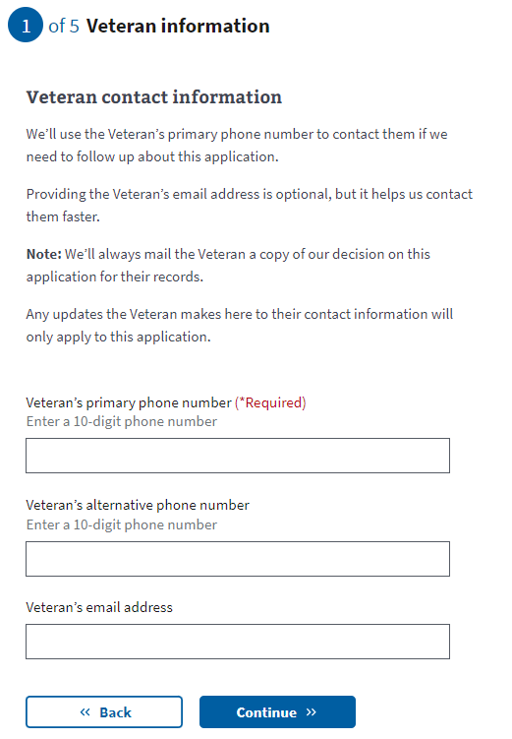

*Fig. 11. Area for primary phone number.*

They can only move on to the next page if they enter all the required information.

### Veteran health care information The Veteran will be asked where they receive or plan to receive VA health care (Fig. 12). This is so the application can be reviewed by a Facility Caregiver Support Program Staff member at that location or an associated facility with Caregiver Support staff. This information is required to complete the form.

### The Veteran can enter their city, state and/or postal code and click on the search button for a list of facilities.

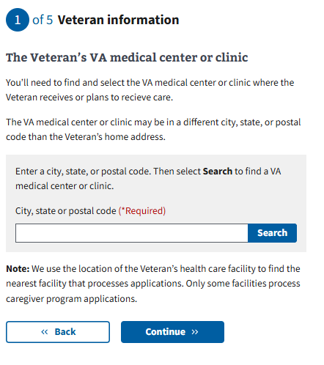

*Fig. 12. Where the Veteran plans to receive care.*

### The results from the search criteria entered will appear on the screen (Fig. 12.1). The facilities are displayed in a nearest to furthest order from the search input location. Once the Veteran makes a selection, the card on the screen will darken to a shaded blue color as well as the radio button will indicate as selected, while the unselected options will remain as white cards.

### 

### 

*Fig. 12.1. Facility search results and selection*

### Once the Veteran clicks Continue, they will either continue to the Primary Caregiver questions, or they may see a new screen to confirm their selected facility (Fig. 13). This page appears if the facility selected does not have Caregiver Support staff and services. The page explains that while the Veteran will receive care at the selected facility, the Caregiver support staff and services are at an associated facility and will be assigned through that facility for the program.

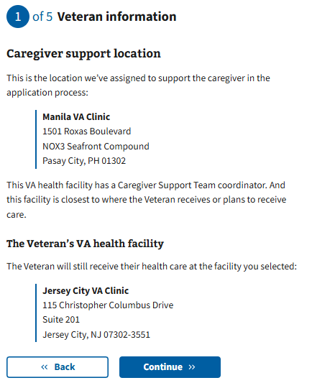

**Fig. 13. Explanation of association between Veteran selected facility and Caregiver support facility**

### 

### **Primary family caregiver Selection**

Next, the Veteran will be asked if they would like to apply for benefits for a primary family caregiver. If Yes, the next step will be to add the primary family caregiver Information. If not, the Veteran will skip to the secondary family caregiver selection. The question must be answered to proceed.

The definition of a primary family caregiver can be accessed through a drop-down link (Fig. 14).

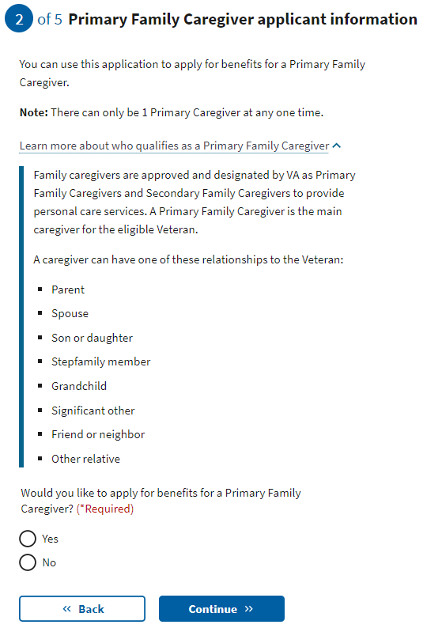*Fig. 14. Definition of primary family caregiver.*

### **Primary family caregiver information**

If the Veteran is applying with a primary family caregiver, the person applying to be the primary family caregiver will be asked to enter general personal information (Fig. 15).

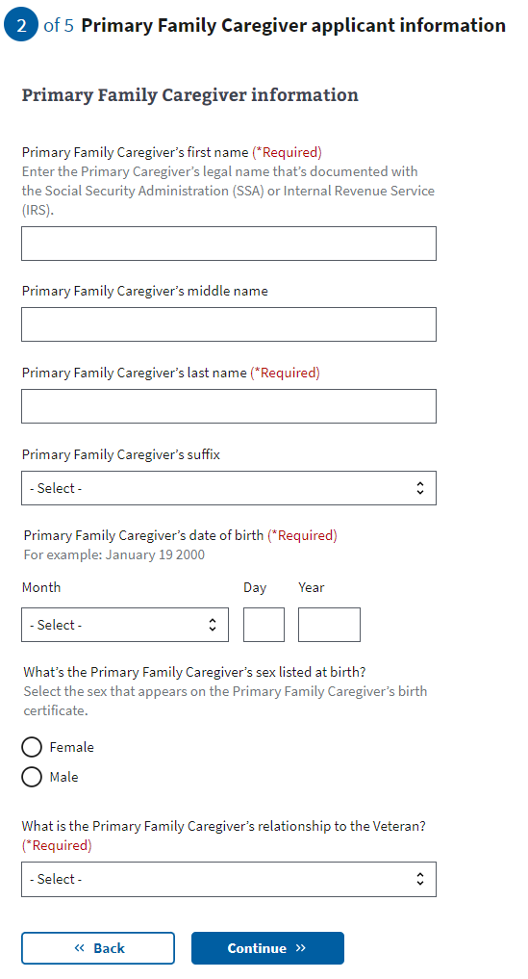*Fig. 15. Primary family caregiver general information.*

The application will tell the primary family caregiver what to fill in. They can only proceed to the next page if they enter all the required information.

The primary family caregiver’s Social Security or tax identification number is requested but not required to apply for the program. The caregiver applicant will receive an error message if they enter a number that is not 9 digits or repeats a number entered elsewhere on the form (Fig. 16).

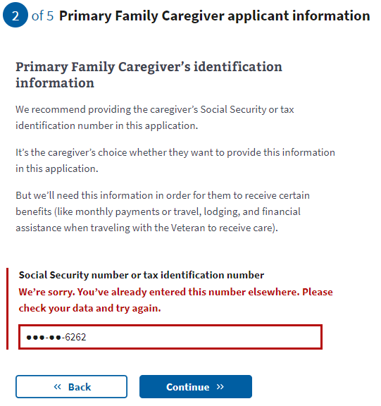*Fig. 16. Social Security or tax ID number error.*

Next, the primary family caregiver will be asked to fill in contact information, including home and mailing addresses (Fig. 17).

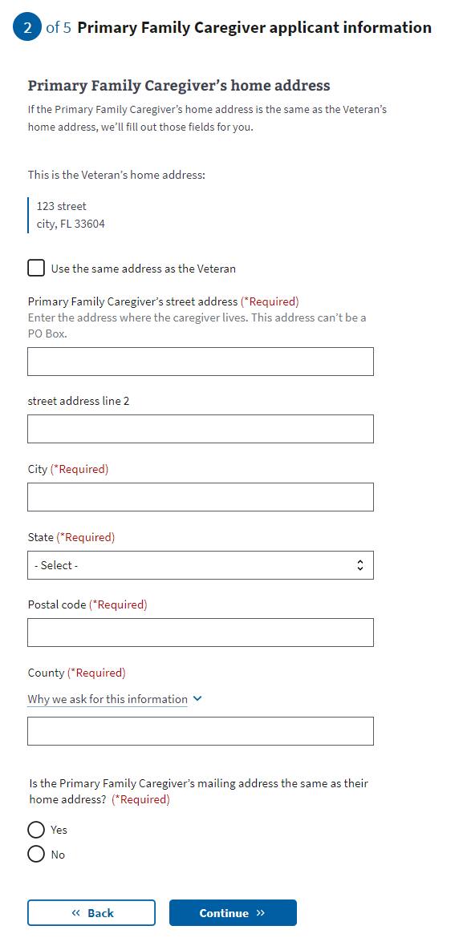*Fig. 17. Caregiver contact information.*

If the Primary Caregiver’s home address is different from their mailing address, they will be asked to provide the mailing address (Fig. 18).

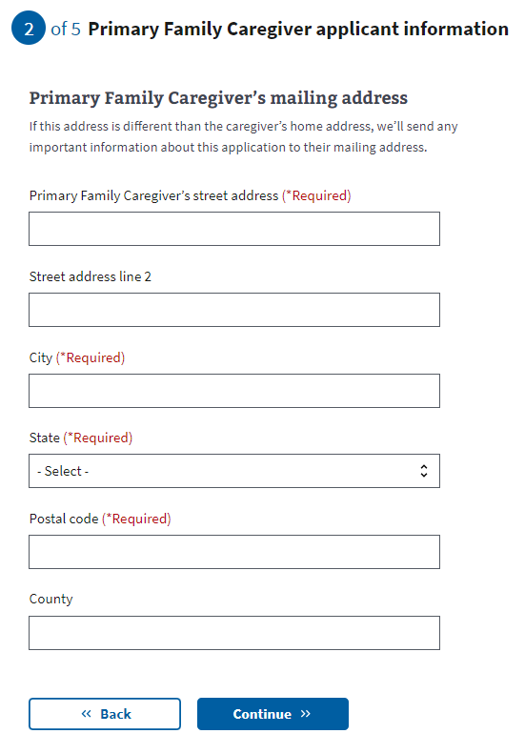*Fig. 18. Caregiver mailing address.*

The primary phone number is required so a Facility Caregiver Support Program staff member can contact the primary family caregiver to discuss the application (Fig. 19). Email is not a required field.

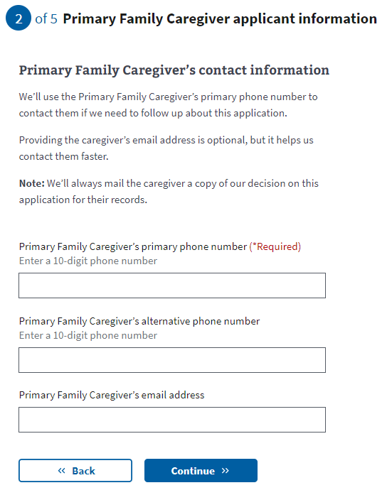

*Fig. 19. Required caregiver phone number.*

### **Secondary family caregiver selection**

Next, the Veteran will be asked if they would like to apply for benefits for a secondary family caregiver (Fig. 20). If Yes, the next step will be to add the secondary family caregiver information. Secondary family caregivers are optional if a primary family caregiver is on the application. Each Veteran can have up to a single primary family caregiver and 2 secondary family caregivers. If there is no primary family caregiver on the application, the Veteran must add a secondary family caregiver(s).

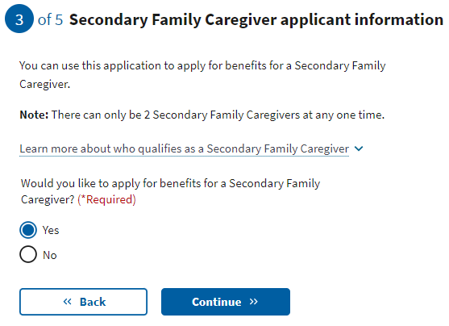

*Fig. 20. Secondary family caregiver.*

The definition of a secondary family caregiver can be accessed by clicking the drop-down link (Fig. 21).

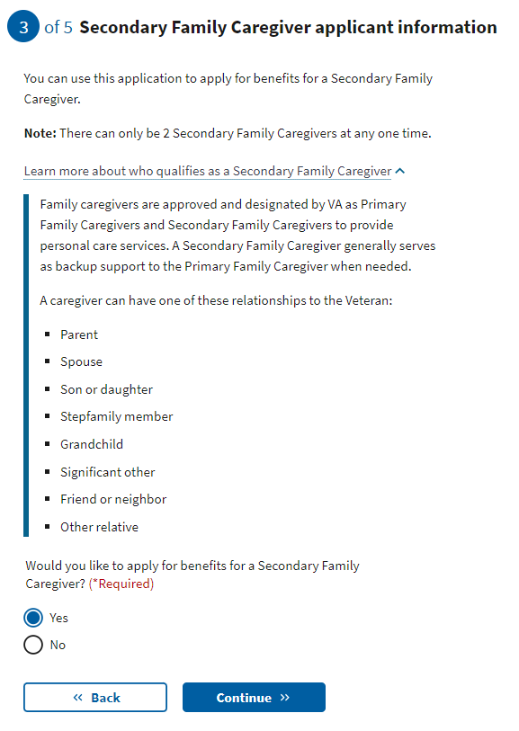

*Fig. 21. Secondary family caregiver definition.*

If the application has a primary family caregiver and the applicant does not add a secondary one, the application will advance to the review screen.

If the application does not have a primary family caregiver and they do not add a secondary family caregiver, they see this error message (Fig. 22):

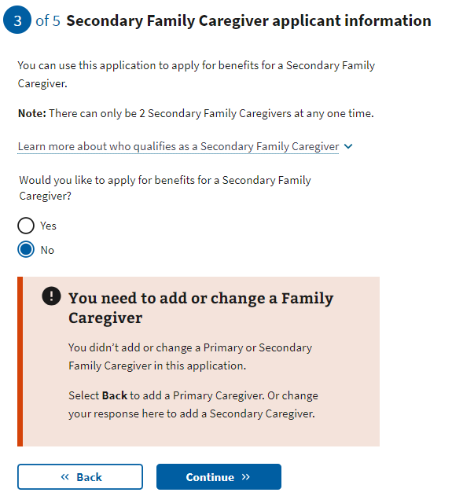*Fig. 22. Family caregiver listing error.*

### **Secondary family caregiver information**

If the applicants add a secondary family caregiver, additional fields will appear.

The person applying to be the secondary family caregiver will be asked to enter general personal information (Fig. 23).

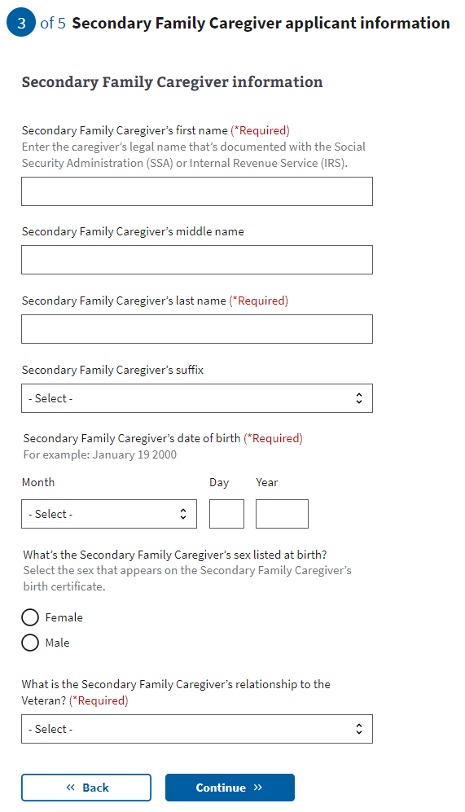*Fig. 23. Secondary family caregiver general information.*The application will tell the secondary family caregiver what to fill in. They can only proceed to the next page if they enter all the required information.

The secondary family caregiver’s Social Security or tax identification number is requested but not required to apply for the program. The caregiver applicant will receive an error message (Fig. 24) if they enter a number that is not 9 digits or that repeats a number entered elsewhere on the form.



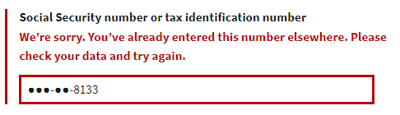**F***ig. 24. Error with secondary family caregiver’s Social Security or tax ID number.*

Next, the secondary family caregiver will be asked to provide contact information, including mailing and home addresses (Fig. 25).

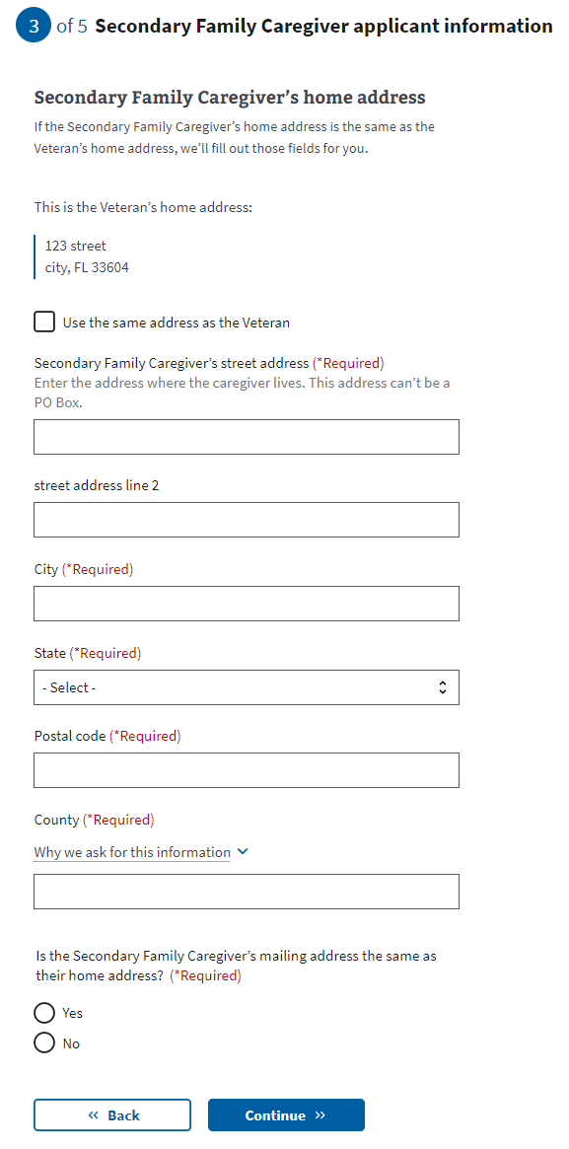*Fig. 25. Secondary caregiver contact info.*

If the secondary caregiver’s home address is different from their mailing address, they will be asked to provide the mailing address (Fig. 26).

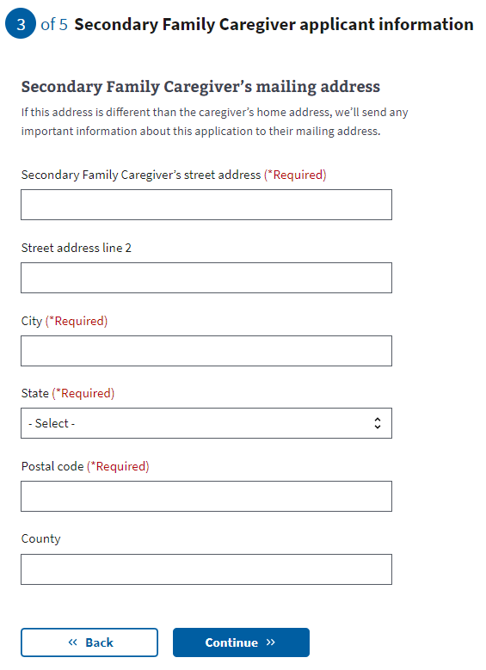

*Fig. 26. Secondary caregiver contact info.*

A primary phone number is required so a Facility Caregiver Support Program staff member can contact the secondary family caregiver to discuss the application (Fig. 27). Email is not a required field.

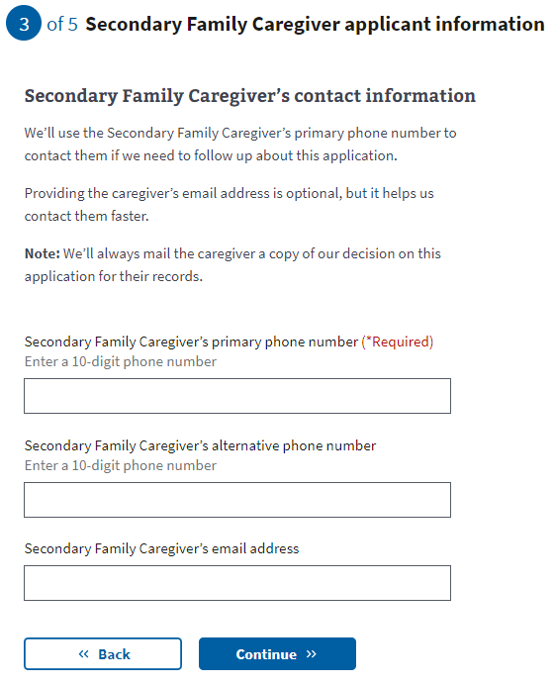

*Fig. 27. Secondary caregiver phone number.*

Applicants are then asked if they would like to add a secondary family caregiver (Fig. 28). If they do not add an additional secondary family caregiver, they will advance to the review screen.

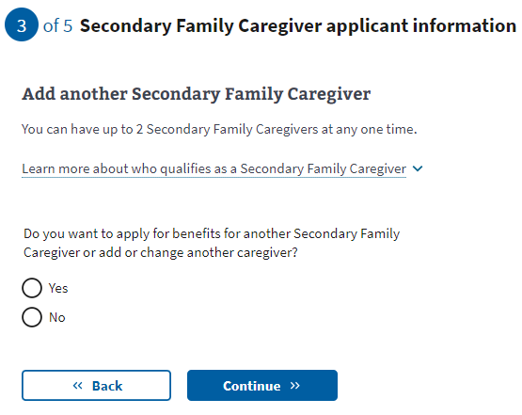*Fig. 28. Option to add an additional secondary family caregiver.* **T**hey will advance to a new screen if they add a secondary family caregiver.  
  
Additional secondary family caregiver information

Next, the person applying to be the additional secondary family caregiver will be asked to enter general personal information (Fig. 29).

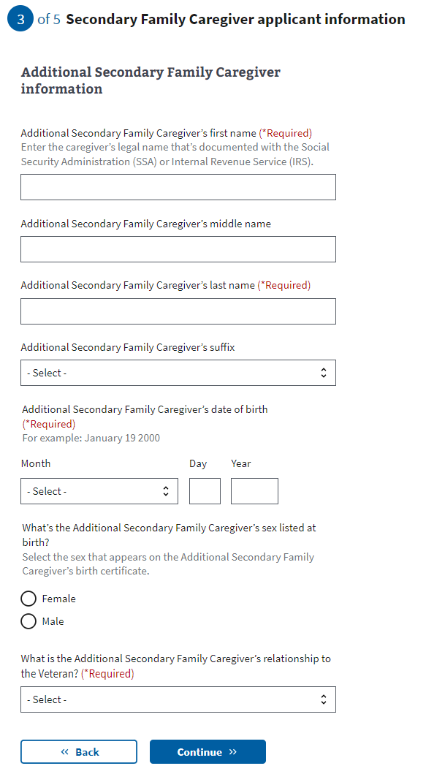*Fig. 29. Additional secondary family caregiver information.*

The application will tell the additional secondary family caregiver what to fill in. If they do not enter all the required information, they will not be allowed to proceed to the  
next page.  
  
The additional secondary family caregiver’s Social Security or tax identification number is requested but not required to apply for the program. The caregiver applicant will receive an error message (Fig. 30) if they enter a number that is not 9 digits or that repeats a number entered elsewhere on the form.

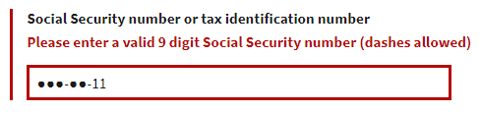

*Fig. 30. Additional secondary family caregiver, Social Security, or tax ID number error.*

Next, the additional secondary family caregiver will be asked to fill in contact information, including home and mailing address (Fig. 31).

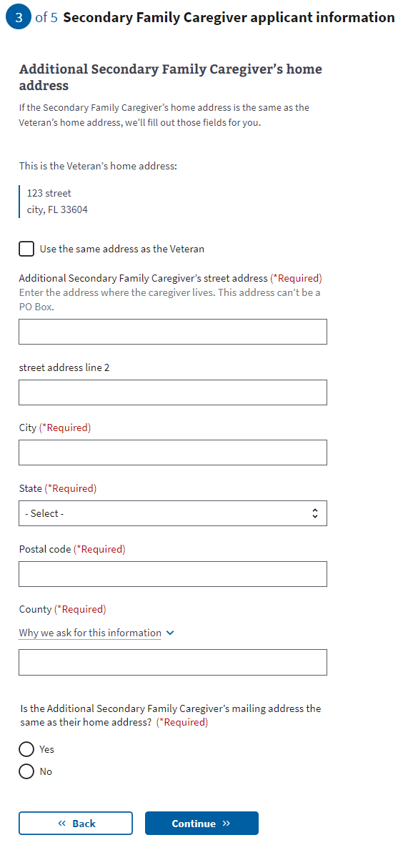

*Fig. 31. Additional secondary family caregiver contact information.*

If the additional secondary caregiver’s home address is different from their mailing address, they will be asked to provide the mailing address (Fig. 32).

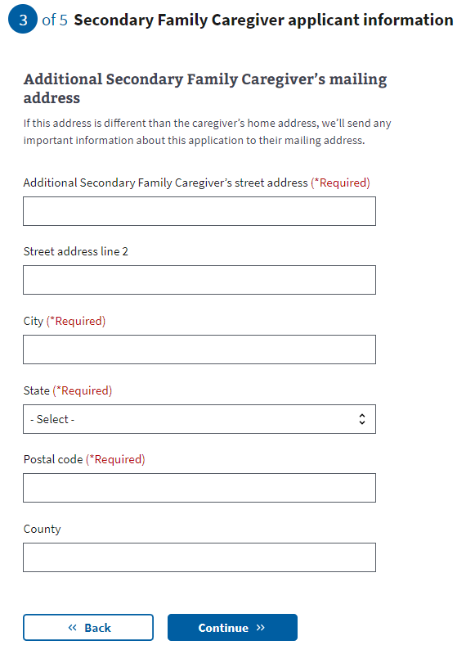*Fig. 32. Additional secondary family caregiver mailing address.*

A primary phone number is required so a Facility Caregiver Support Program staff member can contact the additional secondary family caregiver to discuss the application (Fig. 33). Email is not a required field.

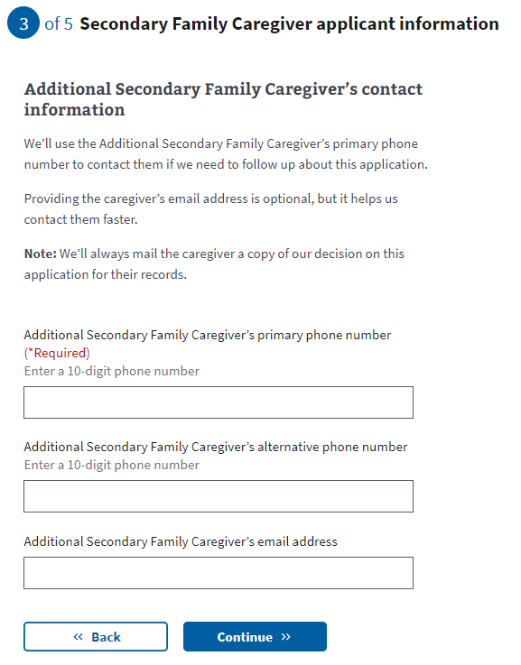*Fig. 33. Additional secondary family caregiver primary phone number.*

### **Representative documentation**

Next, the applicant is asked whether they will sign the application or if their legal representative will. If they indicate that the Veteran will be signing the application, they will advance to the review screen.

They must share legal representative documentation if they indicate that a legal representative will sign the application. This documentation is required if someone other than the Veteran will sign the application.  
  
The requirements for legal documentation (Fig. 35) can be accessed through a drop-down link.

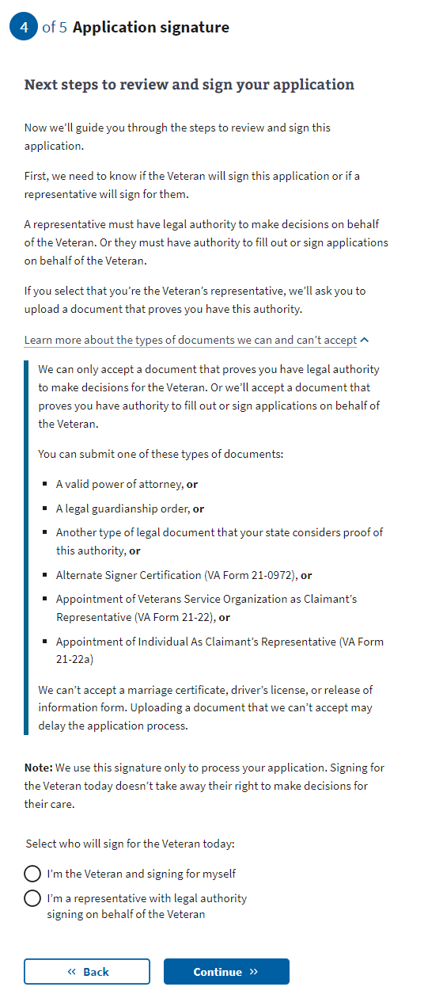

*Fig. 35. Requirements for legal documentation.*

**Upload your supporting documentation**

If the applicant indicates their legal representative will sign the application, they will be taken to the Upload your supporting document screen (Fig. 36). Using the “Upload file” button, applicants can upload a PDF, JPEG, or PNG with a maximum file size of 10 MB.

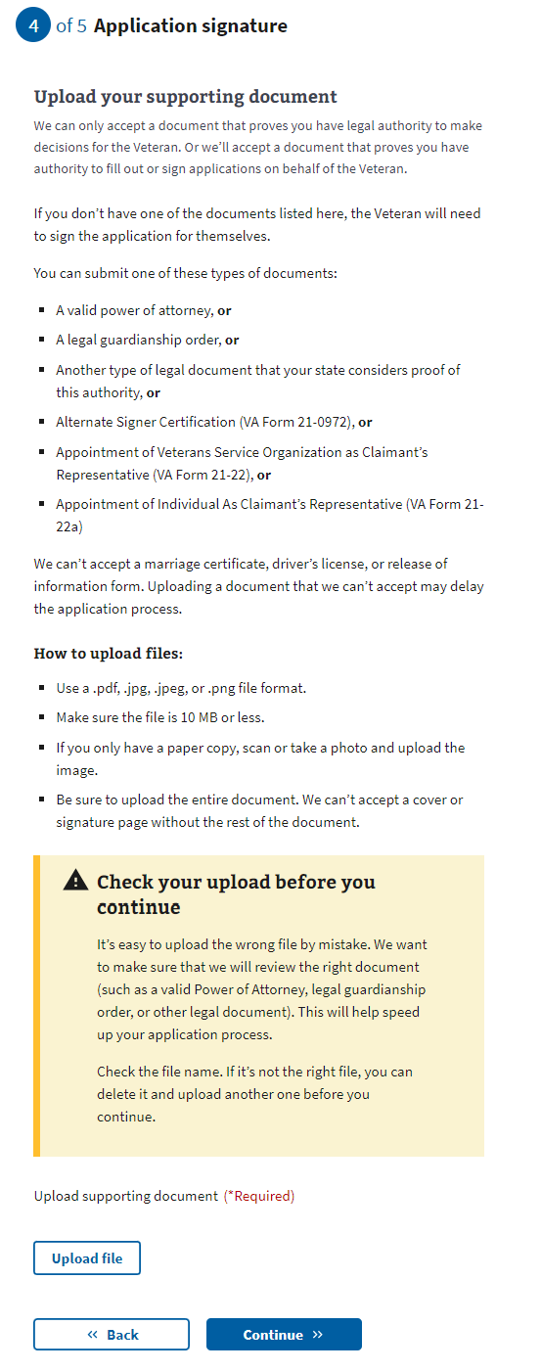

*Fig. 36. Uploading legal representative documentation.*

If the file has been successfully uploaded, the applicant will see a confirmation and be directed to confirm the file name to ensure it is the correct document (Fig. 37). They can delete the file if it is not.

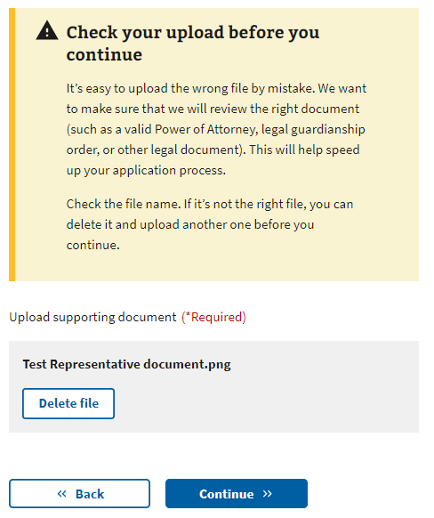*Fig. 37. File upload confirmation.*

**File upload errors**

If a problem uploading a file occurs, an error message will be displayed.

Network issue

If a network issue prevents the file from being uploaded, the user will receive an error (Fig. 38a) and be instructed to try again. Note that the error may be caused by issues within the VA network or issues on the user’s computer or Internet connection. If so, the user may need to try again multiple times or try at a later time.

*Fig. 38a. File upload error—Network issue.*

**File too large**

If the file size is larger than 10 MB, they will receive an error (Fig. 38b) and are instructed to upload a smaller file.

*Fig. 38b. File upload error—File too large.*

**File too small**

If the file size is too small, they will receive an error (Fig. 38c) and are instructed to upload a larger file. Note that the file they are trying to upload may be corrupt. If this error occurs multiple times with the same file, try a different file or different file format.

*Fig. 38c. File upload error—File too small.*

**Wrong file type**

If the file is not one of the supported file types (.pdf, .jpeg, .jpg, or .png), they will receive an error (Fig. 38d) and are instructed to upload a supported file type. Note some browsers will block the applicant from uploading a file that is not supported. If an applicant gets stuck on this error, it would be helpful to help them save the file in  
another format.

*Fig. 38d. File upload error—Wrong file type.*

# **Review and Submission**

### **Reviewing the application**

The last step is the review application page (Fig. 39). Here, the Veteran and each family caregiver can review the information that they’ve entered by clicking on each plus sign next to a section:

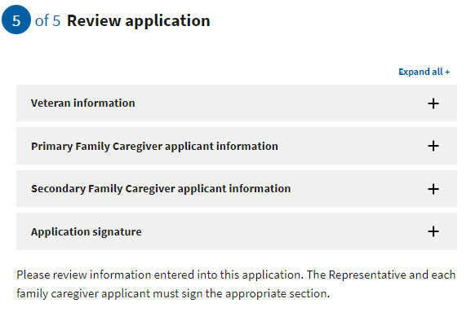*Fig. 39. The review application page.*

Suppose the Veteran and each caregiver applicant click on the plus sign. In that case, the section will open and show what the user entered (Fig. 40). If something looks wrong, the applicant can select the “edit” button and will be able to change the information. To save changes after editing, select the “update page” button.

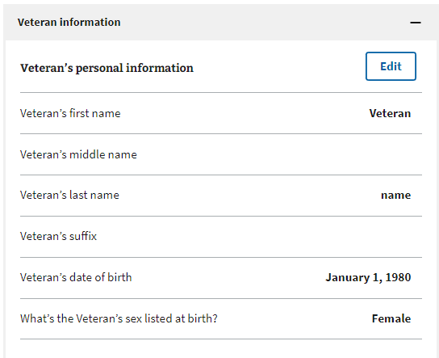

*Fig. 40. Expanding Veteran and caregiver information sections.*

### **Signature Section**

Once the Veteran and each caregiver applicant has reviewed the information and made any changes, they can proceed to the signature section. The Veteran’s statement of truth (Fig. 41) will populate depending on the applicant's choice on the Representative documentation screen. If the applicant indicates that the Veteran will be signing the application, they will be shown this screen. The Veteran can type their full name as they input it into the form and select the “I certify the information is correct and true to the best of my knowledge and belief” checkbox.

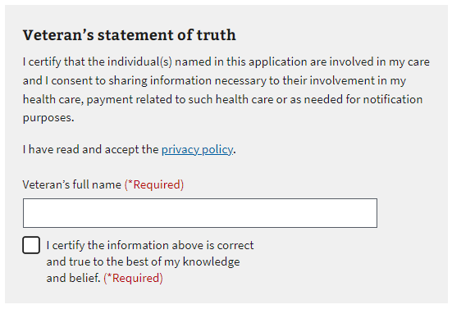*Fig. 41. Veteran’s statement of truth.*

If the name does not match the name input into the form, they will receive this error (Fig. 42). Within the error text, they can see the name input. They can edit the typed signature name and select the “I certify the information is correct and true to the best of my knowledge and belief” checkbox again.

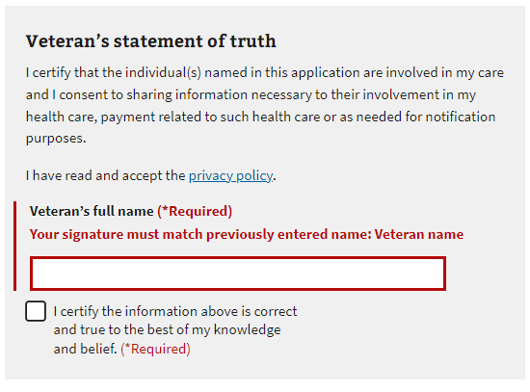*Fig. 42. Signature error.*

Suppose the applicant chooses “I’m a representative with legal authority signing on behalf of the Veteran” on the Representative documentation screen. In that case, they will see this screen (Fig. 43). The representative can input their full name and select the “I certify the information is correct and true to the best of my knowledge and belief” checkbox.

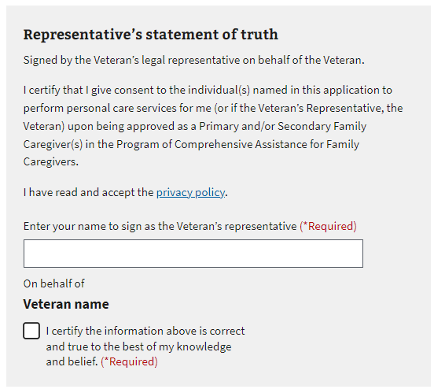*Fig. 43. Signing on behalf of the Veteran.*

Next, each caregiver applicant can type their full name as they input it into the form and select the “I certify the information is correct and true to the best of my knowledge and belief” checkbox (Fig. 44).

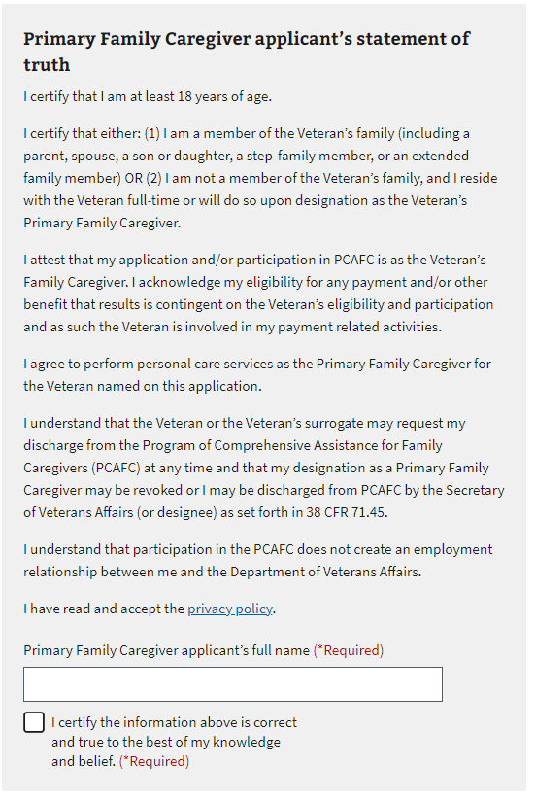*Fig. 44. Primary caregiver’s statement of truth.*

If the name does not match the name input into the form, they will receive this error (Fig. 45). Within the error text, they can see the name input earlier in the form. They can edit the name and select the “I certify the information is correct and true to the best of my knowledge and belief” checkbox again.

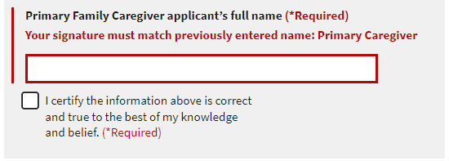*Fig. 45. Primary family caregiver signature error.*

### **Submitting the Application**

Once the Veteran and each caregiver applicant has input their names, they can select to submit their application (Fig. 46).

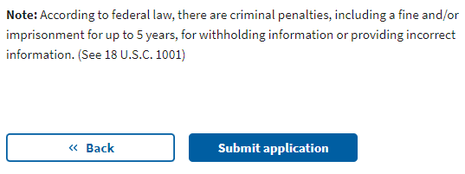*Fig. 46. Submit the application.*

After selecting “submit application,” the applicants will be shown the page below (Fig. 47), which contains a summary of the information and additional information links that can help them understand the process for their application. They will also be able to print out the verification page and a copy of the submitted form to keep for their records.

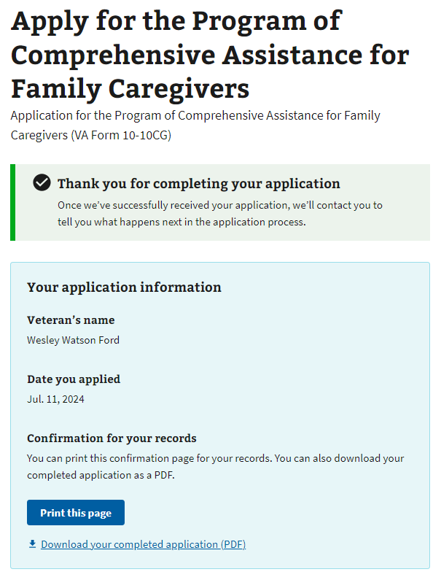

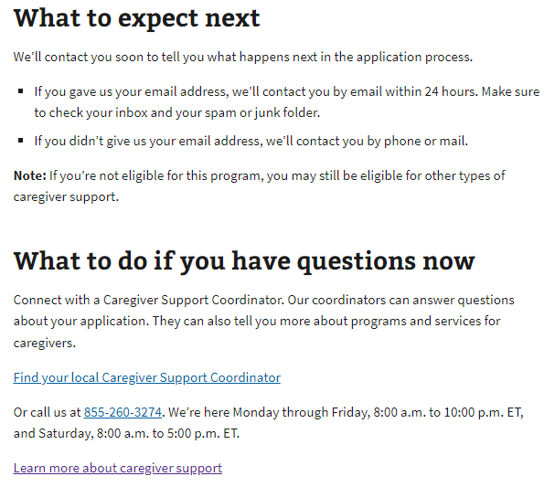

*Fig. 47. Information summary.*

### **Troubleshooting a Submission Error**

If the application fails to submit, the applicant will receive the following error message (Fig. 48) on the Review and Submission page.

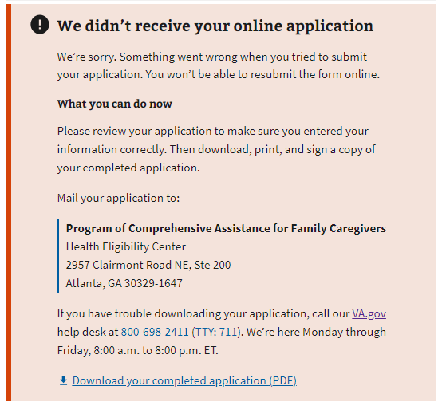*Fig. 48. Application submission failure.*

If the applicant receives this error, they can carefully review the information submitted. If they see an error, they can fix it in the “review” field.

They can only resubmit their online application if they close their browser and start a new session. However, they can click the “download your completed application (PDF)” link at the bottom of the error message, and the completed PDF will be saved to their computer.

Once they print out the completed PDF, the Veteran and each of the family caregiver applicants will need to checkmark the acknowledgment and sign. The application can be mailed to the address listed in the error message.

If the applicant tries to download the PDF but it fails to generate, the applicant will receive one of two error messages:

**Error message 1** (Code 400): Applicants will receive this message if the PDF is generated incorrectly (Fig. 49).

*Fig. 49. Form could not be downloaded.*

**Error message 2** (Code 500): Applicants will receive this message if the VA.gov back end fails (Fig. 50). Applicants who receive this message can try to submit the form later.

*Fig. 50. VA.gov back-end failure.*

# **Table of Figures**

**Fig. 1. 10-10CG eligibility information.****Fig. 2. Beginning the application.****Fig. 3. Information on the Program of Comprehensive Assistance for Family Caregivers.****Fig. 4. Notice of upcoming scheduled maintenance.****Fig. 5. Tool unavailable due to maintenance.****Fig. 6. Pre-application information for the Program of Comprehensive Assistance for Family Caregivers.****Fig. 7. Caregiver Support Program staff member information.****Fig. 8. General Veteran identification information for the 10-10CG application.****Fig. 9. Area where the user enters Veteran’s Social Security or tax information.****Fig. 10. Veteran contact information.****Fig. 11. Area for primary phone number.****Fig. 12. Where the Veteran plans to receive care.**

**Fig. 12.1. Facility search results and selection**

**Fig. 13. Explanation of association between Veteran selected facility and Caregiver support facility****Fig. 14. Definition of primary caregiver.****Fig. 15. Primary family caregiver general information.****Fig. 16. Social Security or tax ID number error.****Fig. 17. Caregiver contact information.****Fig. 18. Caregiver mailing address.**

**Fig. 19. Required caregiver phone number.****Fig. 20. Secondary family caregiver.****Fig. 21. Secondary family caregiver definition.****Fig. 22. Family caregiver listing error.****Fig. 23. Secondary family caregiver general information.****Fig. 24. Error with secondary family caregiver’s Social Security or tax ID number.****Fig. 25. Secondary caregiver contact info.**

**Fig. 26. Caregiver mailing address.****Fig. 27. Secondary caregiver phone number.****Fig. 28. Option to add an additional secondary family caregiver.****Fig. 29. Additional secondary family caregiver information.****Fig. 30. Additional secondary family caregiver, Social Security, or tax ID number error.****Fig. 31. Additional secondary family caregiver contact information.**

**Fig. 32. Additional secondary family caregiver mailing address.****Fig. 33. Additional secondary family caregiver primary phone number.****Fig. 35. Types of legal representative documents accepted.****Fig. 36. Uploading legal representative documentation.****Fig. 37. File upload confirmation.****Fig. 38a. File upload error—Network issue.****Fig. 38b. File upload error—File too large.****Fig. 38c. File upload error—File too small.****Fig. 38d. File upload error—Wrong file type.****Fig. 39. The review application page.****Fig. 40. Expanding Veteran and caregiver information sections.****Fig. 41. Veteran’s statement of truth.****Fig. 42. Signature error.****Fig. 43. Signing on behalf of the Veteran.****Fig. 44. Primary caregiver’s statement of truth.****Fig. 45. Primary family caregiver signature error.****Fig. 46. Submit the application.****Fig. 47. Information summary.****Fig. 48. Application submission failure.****Fig. 49. Form could not be downloaded.****Fig. 50. VA.gov back-end failure.**